**Project 2: Bento-bles**

**Final Report**

**Kathryn Atherton, Celine Chang, Tony Hoch, Sarah Reichstetter, Hongji Zhang**

**ABE 20100, Dr. Mosier**

Reaching the final product, the “Bento-ble”, an international twist on the common Lunchables, was an incredible experience for this team. Given the constraints for this project, the team began brainstorming ideas to create a product that would find success in the market. The challenges presented were quite incredible at first glance, but throughout the brainstorming process the team was encouraged to ignore feasibility and increase the number of ideas. Upon completing the brainstorming process, the team was left with several ideas and eventually decided upon combining two of the most popular among college students in order to create a completely innovative product that would be most likely to fit the constraints of the given project. The following is a detailed report of the design process complete with descriptions of each design phase, various prototyping attempts and the creation and evaluation of the final product.

The original idea for the product was a variety of rice balls that would have cores with ingredients inspired by different cuisines, such as Mediterranean, Chinese, and Indian. The team decided to center its first batch of the product around the Mediterranean cuisine, as the ingredients are easy to obtain and contain the most nutritional value of the recipes brainstormed. The first batch was used to determine the best method to prevent water activity issues; gelatin was the best option tested in this batch. The team also decided with the first batch that the Mediterranean cuisine fit well with the rice-covered snack concept, so the other cuisines were not tested. Finally, in the first batch, the rice was difficult to form into a ball around the core ingredients; a sushi-roll shape formed much more naturally, which changed the rice ball concept into an on-the-go sushi snack with a Mediterranean twist.

During the next test batch, a new idea was brainstormed: a sweet, dessert roll. The roll, about half to three-quarters of the size of the Mediterranean roll, would contain peanut butter, peanuts, and chocolate chips. After creating a test to sample the taste of this roll, the recipe was modified to include chia seeds in order to improve the nutritional value. With this new idea, the team decided to create an entire meal replacement package, rather than a snack; the idea would be similar to a bento box or a Lunchable. The team decided to include, along with the Mediterranean roll and the dessert roll, a side snack of seaweed paper to keep closer to what might traditionally be found in a bento box. With the idea decided upon, the team came up with the name Bento-ble for the product. The product’s formula can be found in Table 1.

*Table 1: Bento-ble Formula*

|  |  |
| --- | --- |
| **Ingredient** | **Mass** |
| Medium grain white rice, cooked | 141 g |
| Hummus | 9 g |
| Carrots | 1 g |
| Red Bell Peppers | 4 g |
| Green Bell Peppers | 4 g |
| Feta Cheese | 1 g |
| Gelatin | 4 g |
| Kale | 5 g |
| Peanut Butter | 2 g |
| Peanuts | 2 g |
| Dark Chocolate Chips | 2 g |
| Chia Seeds | 0.2 g |
| Seaweed | 2.5 g |
| Soy Sauce | 8 g |

As the product became an entire meal replacement instead of a snack, meeting the nutritional requirements was difficult in some aspects. The total mass of the product, 84.7% of which is made up of whole foods, is so large that it was difficult to keep the fat and sodium contents low while keeping the micronutrient contents high. The team was able to meet the goal for keeping the mass of trans fat under 0.1 gram by 96.6% (the total mass of trans fat for Bento-bles is 0.0034 grams); however, meeting the micronutrient goals was less successful. Only the vitamin C goal was met; it was exceeded by 13.3%. None of the other micronutrient goals were met: the vitamin A goal was missed by 86.4%, the calcium goal by 82.0%, and the iron goal by 17.5%. The team attempted to meet the iron goal by using kale instead of romaine lettuce to hold the core ingredients in the Mediterranean roll, the calcium goal by using chia seeds in the dessert roll, and the Vitamin A and C goals by using a variety of vegetables in the Mediterranean roll core, including bell peppers and carrots. However, these efforts were not enough to meet another micronutrient goal. Other ingredients could have been added to boost the other micronutrient contents, but the team decided against it as it would increase the already large mass and calorie content of the Bento-ble, as well as change the well-received taste that the team had developed for the two rolls. In the future, the team would like to do more research into aspects, including core ingredients, rice preparation methods, and the side snack, that can be exchanged or added in order to increase Bento-ble’s nutritional value.

The overall process to create the full Bento-ble can be seen in Figure 1. The figure shows that first, the ingredients are received from shipment and stored in the proper conditions until the preparation begins. Then, simultaneously, the rice is mixed with water and cooked in a rice cooker (in this case, the cooker brand is buffalo) while the core ingredients are prepared; the gelatin mix is placed into hot water and stirred, the vegetables are washed and chopped, and the other ingredients are portioned out (see Table 1 for exact mass values). After 23 minutes, the rice is finished cooking and is portioned out; 96 grams of rice are used in the Mediterranean roll and 45 grams of rice are used in the dessert roll. These portions are then flattened out and then 4 grams of liquid gelatin is spread over the rice. Next, the core ingredients are mixed and placed on top of the rice; the hummus, carrots, red and green bell peppers, feta cheese and kale are used in the Mediterranean roll while the peanut butter, peanuts, dark chocolate chips, and chia seeds are used in the dessert roll. Finally, the rolls are cooled so as to preserve their structural integrity and then packaged with the seaweed and soy sauce before being shipped to the locations where they will be sold.

*Figure 1: Bento-ble Process Diagram*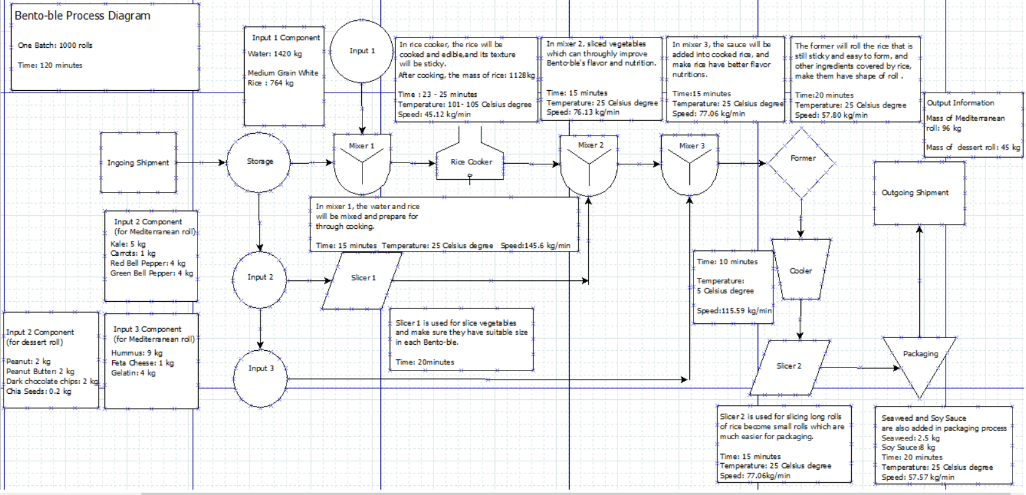

The mass balance for the rolls is derived from laboratory data collected during the three in class labs. The masses were weighed using a scale to measure accurate weights with consistency. The mass balance involved 3 inputs: the dry rice, water, and the core ingredients of the roll. The dry rice and the water were mixed together and cooked, resulting in a water loss. The rice was then made into a pancake form and the core ingredients were added. The mass water mixed with the dry rice was 6 cups, or 1419.53 milliliters, equaling 1419.53 grams. The dry rice weighs 191 grams per cup. The group used 4 cups, or 764 grams of rice. After cooking, the rice weighed 1128 grams; a loss of 291.53 grams of water to steam occurred. The Mediterranean roll used 96 grams of rice. Four grams of gelatin was added to the rice to maintain structural integrity. The core ingredients were added, weighing a total of 24 grams. The same process was used for the dessert roll but with different core ingredients weighing a total of 6.2 grams. The rolls were wrapped up and placed in the bento box while adding 2.5 grams of seaweed and 8 grams of soy sauce. 

*Figure 2: Process Diagram of Team’s Small Scale Kitchen Labs*

The energy balance was attained by using the value of energy produced by the Buffalo rice cooker on their website: 0.65 kilowatts (“索取優惠 / HOT DEALS.”, n.d.). The 0.65 kilowatts was multiplied by the time the rice was cooked for, 23 minutes or 0.383hr, to yield the energy used during the cooking phase. The choi okos equation to find the specific heat of the water/rice mixture. The coefficient values for the water, carbs, protein, and lipids are as follows: 0.129 for water, 0.793 for carbs, 0.069 for protein, and 0.009 for lipids. The energy was calculated using the formula q = m * Cp * ΔT. The final temperature for the rice was not something measurable as it was in enclosed rice cooker. To account for this, the final temperature was set to be 100 °C, the boiling point of water. The latent heat calculation is provided below. Finally, the thermal efficiency was attained by using the formula η = Workout / Qin. There is likely to be a non-negligible amount of error in the final energy balance. This is because of the restrictions placed on the group and the technology available to measure and record the data. For the purposes of understanding the material and the significance of energy in a biological system, the balance is sufficient.

Heating Sushi/Water Mixture

Energy Used:

0.65 kW * 0.383 hr = 896 kJ

Heat Capacity of Rice:

Cp = 4.180 * Xw + 1.711 * Xp + 1.928 * Xf + 1.547 * Xc

Cp= 4.18 * 0.129 + 1.711 * 0.069 + 1.928 * 0.009 + 1.547 * 0.793

Cp = 1.90 J / (g * °C)

Latent Heat:

ΔH = mwater * 2.257 kJ / g

ΔH = 291.53 g * 2.257 kJ / g

ΔH = 658.0 kJ

Energy Absorbed by Rice and Water

ΔH = m * Cp * ΔT + [latent heat]

ΔH = 1128 g * 1.90 J / (g * °C) * (100 °C - 20 °C) + 658.0 kJ

ΔH = 829.4 kJ

Thermal Efficiency:

η = Workout / Qin

η = 829.4 kJ / 896 kJ

η = 92.5%

In a market test, ten individuals tried the Bento-ble for a sensory analysis. The average of the ten responses can be seen in Figure 3. Of all of the aspects of the sensory analysis, the rice got the highest marks; its texture and taste were rated 8.5 and 8 out of 10, respectively, on average, with the texture getting the more consistent high marks (standard deviation of 0.85 compared to the 1.56 standard deviation of the rice taste). The Mediterranean roll and dessert roll received about the same scores, with the Mediterranean roll’s average texture rating being 7.4 out of 10 and taste rating being 7.9 out of 10, while the dessert roll’s average texture received a score of 7.5 out of 10 and the taste a score of 7.6 out of 10. The Mediterranean roll taste with soy sauce received the same score as the main roll taste, though its standard deviation was slightly higher than that of the Mediterranean roll’s score without the sauce (2.08 with soy sauce and 1.60 without). The side snack received a score on par with the rest of the Bento-ble’s items: 7.4 out of 10 on average. For the individual items’ appeal at room temperature, 70% of the consumers found the temperature of the Mediterranean roll to be perfect, 60% found the temperature of the dessert roll to be perfect, and 90% found the temperature of the side snack to be perfect. Unfortunately, the worst scores for the product came in the overall ratings. On average, the consumers rated the compatibility of the entire box and their likeliness to buy this box at a 6.3 out of 10. Overall, the team was pleased with the results, as the feedback was all positive, along with some good comments and improvements to make in the future.

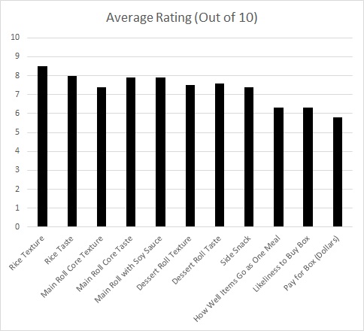

*Figure 3: Average Rating (Out of 10) for Sensory Analysis*

One serving of the product, not including packaging or labor costs, costs $2.15. One batch of 1,000 rolls, or 500 total Bento-bles, takes two hours to produce. Assuming one person who is paid the United States minimum wage of $9 operates the machinery at each of the twelve production stations, the labor cost would be $216 total for one batch, and $0.43 for one Bento-ble, bringing the total cost for one package up to $2.58. According to the website Mr. Take Out Bags, a Three Compartment Sabert Fastpac To Go Container with lids costs $0.78 if at least 750 are bought, bringing the cost for one Bento-ble to $3.37. The cost of operating the machinery to produce the Bento-ble, including a rice cooker, a machine to prepare the core ingredients, a machine to prepare and form the rolls, as well as a machine to package the product, is estimated to be $0.36 per serving. With these estimates, the total cost of Bento-ble production is $3.73. In testing, the test subjects were asked how much they would be willing to pay for a Bento-ble; the average answer was $5.80. If this was the retail price of the Bento-ble, a company selling this product would receive a profit of $2.07 for every Bento-ble sold. This is nearly a 36% profit margin, which is favorable, according to most market analysts.

The strengths of Bento-bles include the fact that it is highly marketable to millennials. The millennial generation is the most open to trying different things, be that a new cuisine or a new type of food (“International Food Trends”, 2016). According to the Mintel Grains and Rice report of April 2016 and Chips and Dips report of February 2016, millennials are also the most likely of all demographics to eat rice and hummus. The flavor innovation with the hummus is another highly marketable aspect of the Bento-ble that will be attractive to the millennial market. The product may also be popular with other generations as 30% of consumers feel that rice keeps them full; being that the main ingredient of the product is rice and that it is a meal replacement option, this may encourage other consumers to purchase a Bento-ble (“Grains and Rice”, 2016). Finally, less-adventurous American consumers may also be willing to try the product due to the simple design and American twist, according to the Mintel International Food Trends report of March 2016.

Some threats to the Bento-ble popularity are the authenticity of the recipe. The millennial generation is very culturally curious, but 78% of consumers want their international foods to be as authentic as possible (“International Food Trends”, 2016). Twisting a popular international food item, such as sushi, may backfire in the market. However, it is believed that with the familiarity of Mediterranean cuisine, the twist will attract the culturally curious as well as those who are less inclined to eat sushi due to their lack of familiarity with the culture and food.

The biggest weakness of the Bento-ble is the amount of rice that is used. The nutritional value of rice is poor, especially for being the main ingredient of the product, and only 14% of consumers believe that “rice contains a lot of nutrients” (“Grains and Rice”, 2016). Although the center of the Mediterranean roll is filled with highly nutritious ingredients, the team should look to research various options for improving the nutritional value of the rice, including using the most nutritional type of rice, brown jasmine, and/or using as little rice as is structurally possible in order to prevent wasting mass and calories on ingredients that are not nutritious.

Currently on the market, the two products most similar to Bento-bles are take-out sushi and Lunchables. Lunchables cost between $1.66 and $2.74 depending on the size and type of meal and contains 260 calories while take-out sushi can cost from $5.50 to over $10.00 depending on what is inside the roll as well as the quality of the sushi and contains about 300 calories. The Bento-ble is closer to the Lunchable in the sense that it provides an entire meal with various aspects, including an entree, a side snack, and a dessert. However, the format of the meal is inspired by sushi, which makes the Bento-ble appealing to fans of both of these options. One Bento-ble is 250 calories, less than both of the other products, and is expected to cost upwards of $3.73, as was discussed previously, making it competitive with both options in price and nutritional value.

Further improvements to the product that the team hopes to pursue include improving the shelf life, maintaining uniformity of ingredients throughout the roll, and perfecting the cooking process of the rice. By adding preservatives to the roll, although it is not the healthiest option for the product, companies will be able to sell the product without losing money to products spoiling on the shelf within a week of production, as was found during testing. During the market test, feedback was given that indicated that some consumers received bites with disproportionate amounts of fillings, which affected the taste ratings. By better mixing the core ingredients to create a uniform taste throughout the product, like sushi achieves, this problem will be addressed, and hopefully fixed. Finally, learning to create the perfect sushi rice that maintains its structural integrity and perfectly sticks to itself takes years to master, and the team did not have enough time to do so during this project. Taking the time to perfect the rice will help with the structural problems the team faced when cutting up the rolls into bite-sized pieces for market testing.

The cost of water, food, and product storage would be extremely different if produced in California versus Indiana. The main ingredients for the Bento-ble are: medium grain white rice, hummus, carrots, red bell peppers, green bell peppers, feta cheese, gelatin, kale, peanut butter, peanuts, dark chocolate chips, chia seeds, seaweed, soy sauce. The following tables are a summary of where each ingredient can be found and what the cost would be:

*Table 2: Fresh Produce of Bento-Bles Location and Cost*

|  |  |  |
| --- | --- | --- |
|  | Main production state | Price |
| medium grain white rice | California/Arkansas (“Rice Background”, n.d.) | $26-30/$21.5-23 per short ton (“National Weekly Rice Summary”, 2016) |
| carrots | California/Michigan (Naeve, 2015) | $0.74 per pound (“Carrots”, 2013)* |
| bell peppers | California (“U.S. bell peppers, 2007) | $30 per cwt (“Table 8 -- California bell peppers”, 2007)* |
| kale | California (Martin, 2014) | $2.81 per pound (“Kale”, n.d.)* |
| peanuts | Georgia (“Peanut Country. USA.”, n.d.) | $409 per ton (“USDA: Weekly National Peanut Prices”, n.d.) |

*using retail price for 2013 (USDA), since current price cannot be found

*Table 3: Cost of Other Ingredients for Bento-bles*

|  |  |  |
| --- | --- | --- |
|  | Brand | Price |
| hummus | Sabra | $2 per 10 oz (“Sabra Hummus”, 2014) |
| feta cheese | Local or retail | $4-9 per pound (“How Much Does FetaCheese Cost”, n.d.) |
| gelatin | Knox | $1.24 per ounce (“Knox Gelatin”, n.d.) |
| dark chocolate chips | Local or retail | $6-12 per pound (“How much do various quality chocolates cost per pound?”, n.d.) |
| peanut butter | Retail average for midwest | $2.268 per pound (“Average Retail Food and Energy Prices”, n.d.) |
| chia seeds | HealthWorks | $4.37 per pound (“Healthworks Chia Seeds”, n.d.) |
| seaweed | One Organic | $2.66 per ounce (“ONE ORGANIC”, n.d.) |
| soy sauce | Kikkoman | $8.336 per qt (“Kikkoman Naturally Brewed Soy Sauce”, n.d.) |

According to these two tables, it would make sense to buy all of the fresh produces from California (except peanuts), to save cost. The other ingredients can be bought from different retail stores across United States, as seen in Table 3. To save more money, the Bento-ble company can make everything from scratch. For example, instead of buying Sabra hummus, chickpeas and other ingredients could be bought to make the company’s own hummus. However, this needs a lot of additional research to complete the revised product.

Water will be needed to clean the produce and cook the rice. Since water is cheaper in Indiana due to the drought in California, it would make sense to build the factory at Indiana. The group could not find the recommended amount of water to clean fresh produce. However, it is known that need 6 cups (1419.53g) of water are needed to make 4 cups of rice. Four cups of rice makes around 4.51 Bento-bles sushi rolls. To make a conservative estimate, it is thought that 3000 grams of water are needed to make 4 Bento-bles sushi rolls. According to the Classification of Service- General Water Service in Indiana, there are two different rates due to the location. Since majority of the cities in Indiana is an Area One Group, it is assumed that the rates would be the following:

*Table 4: Area One Group Water Rates in Indiana*

|  |  |  |
| --- | --- | --- |
|  | Hundred Gallons | Rate per 100 Gallons |
| For the first | 150 | $0.44057 |
| For the next | 37,250 | $0.35536 |
| For all over | 37,400 | $0.20259 |

*General Water Service, Indiana-American Water Company, INC, Effective Jan 29, 2016*

Shipping would also be a huge component of cost. As of 2015, the average pay for truck drivers is around $20 per hour (Skaggs, K., 2015.). It takes around 30 hrs to drive from California to Indiana (for approximation, the route from Sacramento, CA to Indianapolis, IN was used in Google Maps). It takes around 11 hrs to drive from Georgia to Indiana (for approximation, the route from Georgia to Indianapolis, IN was used in Google Maps). This approximation also does not include the various costs for other shipping. Another concern to take into account with the shipping is the Bento-ble’s short shelf life. The longer it takes to ship the product, the shorter the amount of time the Bento-ble can sit on a shelf in a store. As Indiana is more central within the country than California, this location would be more beneficial in that aspect.

The annual average temperature for Sacramento is between 73.6°F and 48.3°F (“Climate Sacramento - California”, n.d.). The annual average temperature for Indianapolis is between 62.4°F and 43.8°F (“Climate Indianapolis - Indiana”, n.d.).

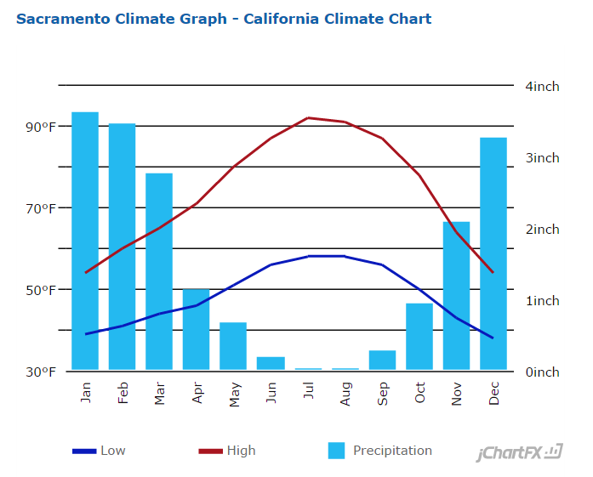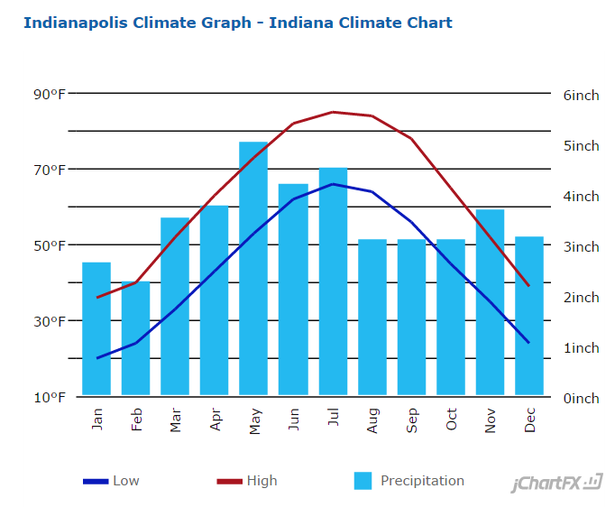

*Figure 4: Climate Graphs of Sacramento and Indianapolis from U.S. Climate Data*

From the charts above, it is noted that Indianapolis is significantly colder than Sacramento in the winter. That means that warm storage for fresh produce from warmer states in the winter would be necessary.

The availability of water in California in comparison to Indiana to produce a Bento-ble will affect the cost and the efficiency of production. In order to cook the rice effectively on a large scale, a significant amount of water is used. The remaining ingredients also require water for natural growth and washing before use.

The challenge of gaining interest of college students with a tasty yet nutritional product is a great undertaking. From the initial brainstorm to the development of the final product, continued awareness of college students’ interests as well as needs were forever present in discussion. Combining the tendency to international curiosity and familiar flavors, the team was able to create a product that will thrive in the college student demographic and provide a significant nutritional benefits. The product also happens to be incredibly inexpensive, which is desireable for college students. Since the initial kitchen lab, the team continuously made improvements to the structural integrity of the product, the nutritional benefits and the flavor combinations. Much of the team’s concerns were due to the high ratio of rice to other ingredients. Although the product is not perfect, it was quite a feat to obtain the success of which is shown in the sensory review data. The product, the “Bento-ble”, has incredible potential in the given market, and is worth pursuing further.

**Bibliography**

3 Compartment Sabert Fastpac To Go Container & Lids. (n.d.). Retrieved December 08, 2016, from http://www.mrtakeoutbags.com/product/sabert-food-storage-containers/xfssac71335b150.html

“Average Retail Food and Energy Prices, U.S. and Midwest Region”. Bureau of Labor Statistics. Retrieved December 09, 2016, from http://www.bls.gov/regions/mid-atlantic/data/AverageRetailFoodAndEnergyPrices_USandMidwest_Table.htm

“Carrots—Average retail price per pound and per cup equivalent, 2013” [table]. Retrieved December 09, 2016, from https://www.ers.usda.gov/webdocs/DataFiles/Fruit_and_Vegetable_Prices__17986//carrots.xlsx

Data, U. C. (n.d.). Climate Indianapolis - Indiana. Retrieved December 09, 2016, from http://www.usclimatedata.com/climate/indianapolis/indiana/united-states/usin1068

Data, U. C. (n.d.). Climate Sacramento - California. Retrieved December 09, 2016, from http://www.usclimatedata.com/climate/sacramento/california/united-states/usca0967

“Healthworks Chia Seeds Raw Pesticide-Free, 3lb” Amazon. Retrieved December 09, 2016, from https://www.amazon.com/Healthworks-Chia-Seeds-Pesticide-Chemical-Free/dp/B0014LNIPI

“How much do various quality chocolates cost per pound?” Quora. Retrieved December 09, 2016, from https://www.quora.com/How-much-do-various-quality-chocolates-cost-per-pound

“How Much Does Feta Cheese Cost?” howmuchisit. Retrieved December 09, 2016, from http://www.howmuchisit.org/how-much-does-feta-cheese-cost/

“Kale—Average retail price per pound and per cup” [table] Retrieved December 09, 2016, from https://www.ers.usda.gov/webdocs/DataFiles/Fruit_and_Vegetable_Prices__17986//kale.xlsx

“Kikkoman Naturally Brewed Soy Sauce, 1.25 qt ”, Walmart. Retrieved December 09,2016, from

https://www.walmart.com/ip/Kikkoman-Naturally-Brewed-Soy-Sauce-1.25qt/10307429

“Knox Gelatin, Unflavored, 32 Count, Net Wt 8-Ounce” Amazon. Retrieved December 09, 2016, from https://www.amazon.com/Knox-Gelatin-Unflavored-Count-8-Ounce/dp/B007Y3HM5C

Martin, A. (May 2014). “Boom Times for Farmers in the United States of Kale. Bloomberg. Retrieved December 09, 2016, from https://www.bloomberg.com/news/articles/2014-05-09/farmers-are-growing-a-lot-more-kale-now-a-census-report

Mintel. (2016, February). Chips and Dips - US. Retrieved from http://academic.mintel.com/display/747654/

Mintel. (2016, April). Grains and Rice - US. Retrieved from http://academic.mintel.com/display/747714/

Mintel. (2016, March). International Food Trends - US. Retrieved from http://academic.mintel.com/display/749048/

Naeve, L. (June, 2015). Carrots. Retrieved December 09, 2016, from

http://www.agmrc.org/commodities-products/vegetables/carrots/

“National Weekly Rice Summary” (Dec, 2016). Retrieved December 09, 2016, from   
https://www.ams.usda.gov/mnreports/lr_gr410.txt

“ONE ORGANIC Sushi Nori Premium Roasted Organic Seaweed (50 Full Sheets)”, Amazon. Retrieved December 09,2016, from

https://www.amazon.com/ORGANIC-Premium-Roasted-Organic-Seaweed/dp/B00I01ZXYE/ref=pd_sbs_325_t_0?_encoding=UTF8&refRID=DGY2YW1FMB7RYFXTQTAH&th=1

“Peanut Country. U.S.A.”, National Peanut Board. Retrieved December 09, 2016, from http://nationalpeanutboard.org/peanut-info/peanut-country-usa.htm

“Rice Background.” (n.d.). Retrieved December 09, 2016, from https://www.ers.usda.gov/topics/crops/rice/background/

“Sabra Hummus, Only $1.98 at Walmart!” (2014) The Krazy Coupon Lady. Retrieved December 09, 2016, from http://thekrazycouponlady.com/2014/09/26/sabra-spinach-artichoke-hummus-1-98-walmart/

Skaggs, K. (2015, February 27). Average Hourly Pay for Truck Drivers. Retrieved December 09, 2016, from http://bigcitydriver.com/2015/02/average-hourly-pay-for-truck-drivers/

“'Table 8-- California bell peppers: Acreage, yield, production, and value, 1960-2007.” [table] Retrieved December 09, 2016, from usda.mannlib.cornell.edu/usda/ers/BellAndChile/Table08.xls

“U.S. bell peppers: Production by State, 1960-2007” [table]. Retrieved December 09, 2016, from

usda.mannlib.cornell.edu/usda/ers/BellAndChile/Table06.xls

“USDA: Weekly National Peanut Prices” AGFAX Retrieved December 09, 2016, from http://agfax.com/tag/peanut-prices/

索取優惠 / HOT DEALS. (n.d.). Retrieved December 09, 2016, from http://www.buffalocookware.com/en/2-pro-detail.php?s=79